Date

Team ID

Project Name

Maximum Marks

Empathy Map Canvas:

An empathy map is a simple, e

behaviours and attitudes.

It is a useful tool to helps teams

Creating an effective solution r

is experiencing it. The exercise

the user’s perspective along wit

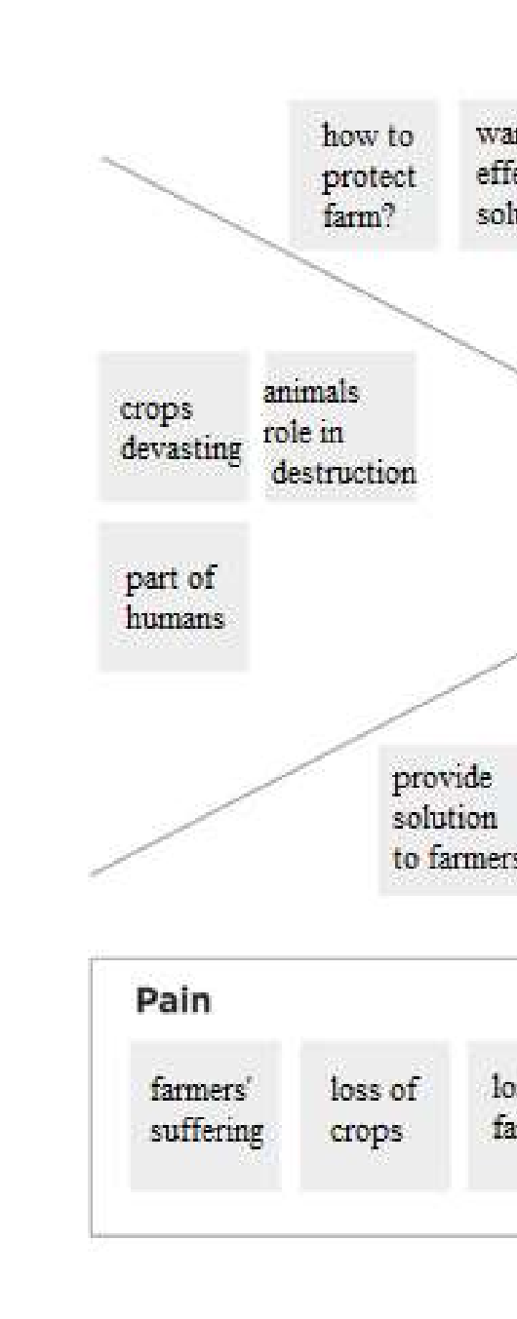

Ideation Phase

Empathize & Discover

21

October

2022

PNT2022TMID

2

3850

IoT Based Crop Protection System for

4

Marks

asy

-

to

-

digest visual that captures knowledge

better understand their users.

equires understanding the true problem

and th

of creating the map helps participants consid

h his or her goals and challenges.

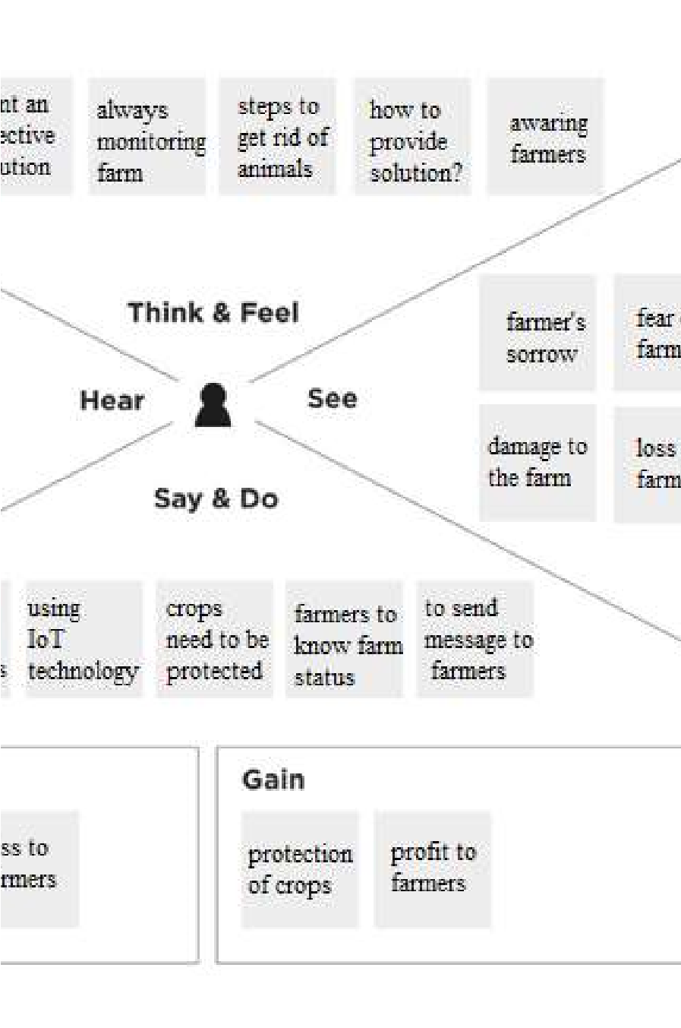

Agriculture

about a user’s

e person who

er things from

